Stability and Simple Trusses
There is an important characteristic of a useful truss: it must be stable, which is to say that it should not move freely in any direction. Below are some configurations of members joined at the ends. The first shown is the most basic triangular truss. The left support only allows connected members to rotate. The right support additionally allows horizontal movement. This configuration is stable, because there is no motion which can freely occur.
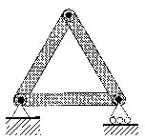
Two members connected at a joint form a hinged arch, as shown below. A hinged arch may be added to any stable truss to form another stable truss, as long as the angle of the arch is other than 180º. A truss which can be assembled in this manner is called a simple truss.
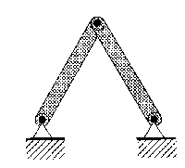
Shown next is a square configuration. This is unstable, because the side pieces will lean over freely as the top is pushed horizontally. How would this be stabilized?
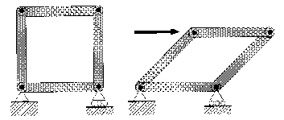
Lastly, we see that a pentagonal configuration is also unstable, because as points A and B move apart, point C is free to move down. What is the smallest number of members required to make this stable? In a similar fashion, all but the triangle will be unstable, so the triangle is basic unit of any truss structure.
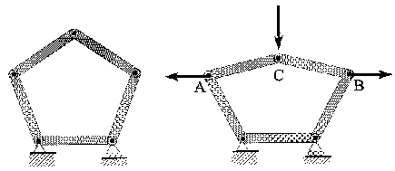
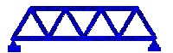Return to Home Page.

The Long and Short of It
Another special feature of trusses is that the members don't bend. They get pulled apart (in tension) and pushed together (compression), but they don't bend like the plank does when you stand on it. The members stay straight from end to end until they break. This doesn't mean the bridge will stay straight, though. As heavier loads are put on the bridge, it will still sag in the middle. This is because the individual members of the truss are getting longer (if they are in tension) and shorter (if they are in compression).

A Belt Isn't the Only Thing that Buckles
Many materials, in theory, have the same strength when being squeezed together (in compression) as they do when pulled apart (in tension). The problem is that if you press the two ends of a thin member (like a ruler) together, it doesn't simply stay straight and get shorter, but instead it bends out to the side. This is called buckling, which is the way that most tall, skinny things break when compressed end-to-end.

How Could My Truss Fail?
There are three ways your truss can fail. If a member buckles enough, it will bend and break in the direction in which the craft sticks have a low moment of inertia. This may be prevented if the loading frame supports partially buckled members. Another type of failure is that a craft stick pulls apart in the middle in tension. The third type of failure possible is joint break-out. This is when the craft stick breaks right where the bolt is connected.

The Long and Short of It
Another special feature of trusses is that the members don't bend. They get pulled apart (in tension) and pushed together (compression), but they don't bend like the plank does when you stand on it. The members stay straight from end to end until they break. This doesn't mean the bridge will stay straight, though. As heavier loads are put on the bridge, it will still sag in the middle. This is because the individual members of the truss are getting longer (if they are in tension) and shorter (if they are in compression).

A Belt Isn't the Only Thing that Buckles
Many materials, in theory, have the same strength when being squeezed together (in compression) as they do when pulled apart (in tension). The problem is that if you press the two ends of a thin member (like a ruler) together, it doesn't simply stay straight and get shorter, but instead it bends out to the side. This is called buckling, which is the way that most tall, skinny things break when compressed end-to-end.

How Could My Truss Fail?
There are three ways your truss can fail. If a member buckles enough, it will bend and break in the direction in which the craft sticks have a low moment of inertia. This may be prevented if the loading frame supports partially buckled members. Another type of failure is that a craft stick pulls apart in the middle in tension. The third type of failure possible is joint break-out. This is when the craft stick breaks right where the bolt is connected.

Problem Statement

Objectives:
- Build a truss bridge which will span at least 18".
- Build it to support as much weight as possible.
- Use as little material as possible.

Materials:
- 27 full-size craft sticks with holes drilled in the ends
- 29 shortened craft sticks with holes drilled in the ends
- 20 of #7 bolts and matching nuts

Equipment:
- Ruler, Screwdriver, Wrench

Loading:
You must designate one or two bolts to which a wire will connect to attach the load as shown in the figure. Each load point must be more than 4 inches from the inside edge of the support (toward the center).

Procedure:
- You will work in teams.
- Count your sticks, bolts and nuts.
- Verify that all your materials are of acceptable quantity and quality.
  - Craft sticks which are damaged or improperly drilled may be replaced.
- Assemble a truss which meets the three objectives keeping in mind the principles we have discussed today.
- Keep a record of the following for your completed truss:

  - a diagram of your design
  - the number of long members used
  - the number of short members used
  - the number of nut-bolt pairs used
  - the weight at which your truss fails

Excerpts from the ACSD (American Craft Stick Design) Code:
- Nuts must be fully seated (bolt threads show).
- All structures must be stable or they cannot be loaded.

Loading diagram:
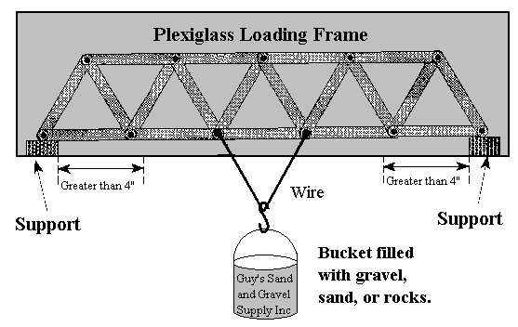
Scoring:
- Trusses will be scored as to how well the second and third objectives are met.
- The higher the load the truss supports, the higher the score.
- The less material used in its construction, the higher the score.
The score is calculated as follows:
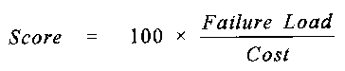
Cost is calculated as follows:

LOAD FRAME FABRICATION

(as fabricated by The University of Florida)

Malerials:
- 12" x 24" x 1/4" Lexan Sheets (Quantity = 2)
- 2" x 2" x 24" long wood (any species); cut into four 1" long pieces (exact), and two 8" long pieces (approximate)
- #8 - 32 x 2.5" Wood Screws (Qty = 4)
- #6 - 32 x 2" Machine Screws and Nuts (Qty = 4)

Equipment:
- Drill (drill press and hand drill)
- 3/16", 5/32", l/8" Drill Bits
- Screwdriver

Instructions:
- Cut the wood into four 1" long (exact) and two 8" long pieces if this needs to be done.
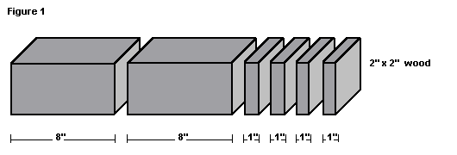
- Drill a 5/32" hole through the center of each 1" long piece.
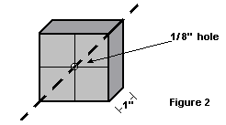
- Drill two 3/16" holes through each 8" piece (see diagram). Use the drill press.
- Using the 3/16" holes of the 8" piece as a rough guide, drill two 1/8" holes 1" deep into the underside of only two of the 1" long pieces (see diagram). Use the drill press.
- Screw in a #8-32 x 2.5" wood screw through the 8" long piece and into the 1" long piece for each hole as shown in the diagram. Assembly of the two bottom wooden supports should now be finished.
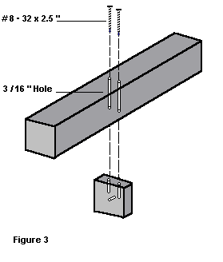
- Align the two wooden supporns on one lexan sheet so that there is an 18" span measured along the inside of each support: approximate symmetry (see diagram). Mark where the holes on the wood are on the lexan sheets for drill guides. Do this for both sheets.
- Drill the two lower holes on the lexan sheets using the 5/32" drill bit and the hand drill. Drill slowly and in short bursts so that the lexan will not melt. These holes are for attaching the bottom Supports.
- Place the other two 1" wood pieces on the top corner of the lexan sheets and mark the holes (see diagram).
- Drill the two top holes on the lexan sheets using the 5/32" drill bit and the hand drill. Again, drill slowly and in short bursts.
- Screw the lexan sheets and the 1" wood separators together with the #6-32 x 2" machine screws and nuts. Do the same for the bottom supports.
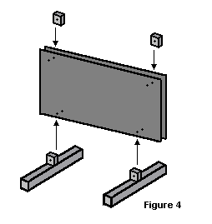
- The truss is now ready to be placed into the load frame for testing.

Assembly Instructions For Loading Frame

Materials:
- 12" x 23" x 0.25" Lexan Sheet (2)
- 2" x 2" x 24" Wood (any species); cut into four 1" long pieces (exact), and two 8" long pieces (approximate)
- #8-32 x 2.5" Wood Screws, Flat Head (4)
- #6-32 x 2" Machine Screws and Nuts, Round Head (4)
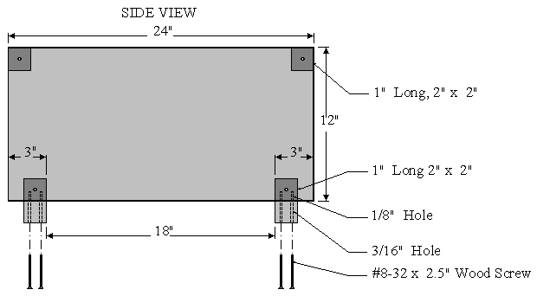
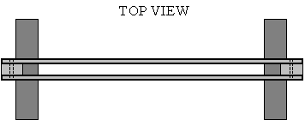.....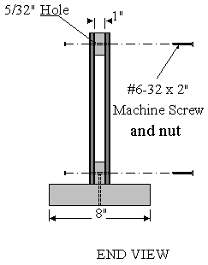

Structural Model Project
Arch 324/524, Introduction to Structural Design, University of Virginia  Copyright © 1996-2000 Kirk Martini. Last Modified Tuesday, 19-Feb-02 13:16:08 |  | Table of  Contents

Task
You and a teammate are to build a working, demountable structural model with the following constraints.

Model Materials
  - The materials are limited to the following:
    - 1/16" chip board.
    - 1/8" foam core board.
    - 1/4" wood dowels, or smaller.
    - 1/4"x1/4" basswood sticks, or smaller.
    - Lightweight cotton twine (Duraline Cotton Wrapping Twine or equivalent).
    - Alliance Size 16 Rubber Bands (medium sized rubber bands. No fan belts, or other industrial rubber products, please.)
No adhesive products (e.g. tape or glue) are allowed in making the model.
In addition to making the model, you will also need to make a box to put it in, as described below.

Model Transport and Assembly
The model must be demountable and transportable in a box with the dimensions shown below.  The dimensions are from outside face to outside face. You will need to make the box in addition to the model. Any materials are acceptable in making the box. | 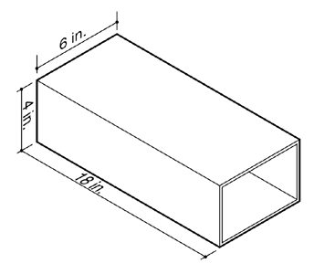
Each lab section will test during the regular lab time. The testing will be done in the 1st floor lounge. The schedule for testing will be as follows:
15 minutes  (exactly) | Model Assembly. The 15-minute limit on model assembly is very firm. Models not completely assembled in 15 minutes will be tested "as is."
10 minutes | Model review.
60 minutes | Model testing.

Model Loading and Supports
The figure shows a section diagram of the load and support conditions, The strap is 1.5 inches wide, and made of canvas.
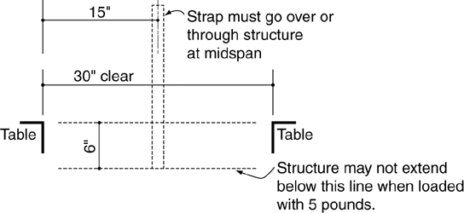

Objectives and Evaluation
Each person's design will be evaluated on the following criteria:
  - Load carrying capacity: The amount of load the structure carries up to the point of collapse.
  - Critical anlaysis of beauty: The aesthetic qualities of the assembled structure, as evaluated by other members of the lab section.
  - Critical anlaysis of strength: The apparent strength of the structure, as evaluated by other members of the lab section.
  - Teamwork: The ability to work productively in an assigned group.
These criteria will be evaluated as follows:
  - Load carrying capacity: (70%) This will be based on the amount of load your structure carries.
  - Critical anlaysis of beauty: (10%) This will be based on the results of a voting process among section members, where people identify the structures they consider the most beautiful.
  - Critical anlaysis of strengthh: (10%) This will be based on the results of a voting process among section members, where people identify the structures they think will be the strongest. (You get credit for making people think you've got a strong structure, whether it is or not).
  - Teamwork: (10%) This will be based on mutual assessment by you and your teammate.

Deadline
Stop work at 11:00 AM, Thursday March 7 (for all sections). Models will be tested during the section meetings on that day.
Project teams up to 8 persons

Structural Model Project
Design, Critical Analysis, Communication, and Teamwork

Arch 324, Introduction to Structural Design, University of Virginia
Last updated Tuesday, February 23, 1999, at 10:40 AM Copyright © 1996, 1997 Kirk Martini

Task
You and a teammate are to build a working structural model from a standard kit of parts.
The kit of parts includes the following:
  - Ten 2"x15" strips of 1/16" chip board.
  - Ten 2"x15" sheet of foam core board, 1/4" thick or less.
  - 200 inches of 1/8" x 1/8" basswood.
  - 100 wooden toothpicks.
  - 30 feet of Duraline Cotton Wrapping Twine.
  - 50 Alliance Size 16 Rubber Bands.
The chipboard, foam core, and basswood are available at the AA Supply Store; the other items are available at the Newcomb Hall book store; several teams can purchase items as a group. No adhesive products (e.g. tape or glue) are allowed. The figure below shows the load and support conditions, The strap is 1.5 inches wide, and made of canvas.
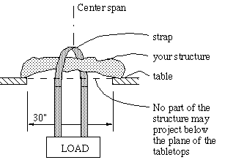

Procedure
Projects will be tested during the section meeting times on Thursday March 5. If the weather is good, we will test the projects outside, otherwise we will use room 105. The process begins with an evaluation and prediction phase where each person in the section will predict for each structure the number of pounds they expect it to carry; this will be followed by a testing phase where each model is loaded to failure.

Objectives and Evaluation
The project seeks to develop and evaluate three abilities:
  - Design: The ability to conceive and build a good structure.
  - Critical Analysis: The ability to evaluate and identify good and bad structures.
  - Communication: The ability to convince other people that your structure is good.
  - Teamwork: The ability to work productively in an assigned group.
These abilities will be evaluated as follows:
  - Design: (70%) This will be based on the amount of load your structure carries.
  - Critical Analysis: (10%) This will be based on the accuracy of your predictions in the prediction phase.
  - Communication: (10%) This will be based on the average strength predicted by people in your section, regardless of how much load it actually carried. (You get credit for making people think you've got a strong structure, whether it is or not).
  - Teamwork: (10%) This will be based on mutual assessment by you and your teammate.

Schedule
Time | Task or Product
Fri 26 Feb to  Thu 4 Mar | Purchase the kit of parts, confer with your partner, and begin developing a conceptual design. There will be time during the Thursday lab meet with your partner and discuss your concept with the teaching assistants. Bring sketches of design ideas.
Fri 5 Mar to  Wed 10 Mar | Build the model.
Thu 11 Mar | Evaluation and testing.

Trusses

What are they ?
Examples
Gallery

Introduction
In this section you will be given a brief introduction to trusses and their use in civil/structural engineering. Some examples of trusses have been included and there is a small gallery showing the various ways trusses can be used in the real world.

What are they ?
The dictionary definition of a truss is 'a braced framework of ties, beams or bars, usually arranged in a series of triangles, as for the support of a roof, aeroplane, or bridge'. The trusses that you will be taught to analyse (using the stiffness method) in this computer package will be of the 2-D pin jointed type. Though the stiffness method can be extended to solve the more complex 'frame problems', we won't be looking at that here.
The truss structures which we shall be looking at will be 2-D as already stated (i.e. they can be represented fully by a side elevation drawing). Trusses are made from straight members (e.g. steel sections) connected by joints (e.g. bolts) to form a rigid shape, usually made up of triangles. The trusses we are concerned with at the moment are 'pin-jointed' trusses, this means that the members are free to rotate at the joints and the joints cannot support any moment.
A truss is one of the most simple pieces of engineering found in the construction industry, they have been used for hundreds of years and will no doubt be used for many years to come. The relative simplicity and low cost in analysing and fabricating a truss structure has lead to it's popularity.
Trusses are often designed to utilize the material they're built from in the most efficient way possible. As you should know by now, steel members have far greater axial strength when they're in tension as opposed to compression (particularly if they're slender). For this reason it is of prime interest to keep as many members as possible in tension under working loads, designing for this is not always easy though.

Examples
There are examples of trusses all around us, many are hidden from sight underneath cladding or bricking but there are also many good examples of truss structures left exposed. The range of trusses in use today is quite diverse, they vary enormously in shape and size. The diagram below shows a range of different types of truss, notice the variety of shapes and the contrasting amounts of complexity.
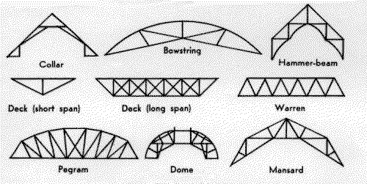
Types of Trusses

On the smaller scale, trusses have been used for the construction of pitched roofing for homes, here the material used in usually wood as it is relatively cheap, light and easy to work with. Trusses found in bigger buildings such as factories often have to span greater distances and carry more loading, here steel is used instead of wood because of it's higher strength. Another very common example of trusses is found in the form of supports for motorway signs, so next time you're on the M4 look out for them.
On a larger scale, trusses are often used to carry a loading over a large span, e.g. a footbridge over a road. In the case of a footbridge the loading is fairly low and you can get away with quite thin members for the truss.
On the largest scale, trusses can be found in bridges which can traverve hundreds of meters between supports and carry heavy loading in the form of trains and other vehicles. These huge trusses have to be constructed from suitably large members as they are under much higher loading, but, the basic principle remains the same as the smaller trusses.
There are three main constraints to consider when analysing a 2-D pin-jointed truss. Firstly, equilibrium must be satisfied. Secondly, the material law must be satisfied, i.e. strains produced in members are directly related to the stresses in those members (in accordance with Hooke's law). Lastly there is the condition of compatability, this basically states that all the members stay connected to the joints in the same way as they were at the start. This last condition implies that if a member's change in length moves the position of a joint at one of it's ends, then, any other member attatched to this joint will be changed in length so that it is still attatched to the joint and so on.

